NLP Chatbot Development using Dialogflow
Design Document

Version 1.0



Group Id: F24PROJECT38A67

Supervisor Name : Abdullah Qamar

Revision History
Date (dd/mm/yyyy) | Version | Description | Author
26/02/2025 | 1.0 | This project involves creating an AI-driven chatbot specifically designed for restaurants using Google Dialogflow. The chatbot will simplify key operations, such as making table reservations, exploring menu options, placing orders, and handling customer inquiries. The primary aim is to improve customer satisfaction and streamline the overall restaurant workflow.  With this chatbot, customers will be able to conveniently reserve tables, view menu items, place orders, and receive prompt responses to their questions, all through a conversational platform. By leveraging Natural Language Processing (NLP), the chatbot ensures smooth communication, reduces customer waiting times, and alleviates the workload of restaurant staff, contributing to a more efficient operation. | BC230424569

Table of Contents

- Introduction of Design Document
- Entity Relationship Diagram (ERD)
- Sequence Diagrams
- Architecture Design Diagram
- Class Diagram
- Database Design
- Interface Design
- Test Cases

Introduction of Design Document
- This project focuses on developing a restaurant chatbot using Google Dialogflow. The system is built to handle common restaurant interactions such as browsing the menu, placing food orders, asking for operating hours, and checking for special offers.

- The purpose of this chatbot will be to handle common restaurant interactions such as browsing the menu, placing food orders, asking for operating hours, and checking for special offers and checking the order status. Users can also ask common FAQs from this chatbot. Instead of relying on staff for every customer request, the chatbot provides a quick, conversational interface that responds to user inputs in real time.

- The design of this chatbot should be focused on making restaurant services more efficient, especially during busy hours. The chatbot is built in a way that makes it easy for developers to work with. It uses fixed commands called intents and connects to backend code (webhook) to answer both simple and more detailed questions.

- This document outlines the complete design of the system, including architecture diagrams, entity relationships, sequence flows, interface designs, and test cases — all aimed at guiding development, testing, and future maintenance.

Entity Relationship Diagram (ERD) (To be developed using Microsoft Visio or any other drawing software of your choice)
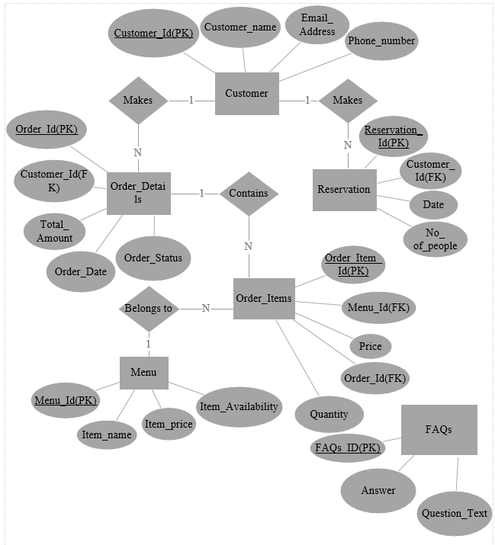
Sequence Diagrams (To be developed using Rational Rose or any other drawing software of your choice)
Architecture Design Diagram
Class Diagram

Database Design

Interface Design

First Screenshot:

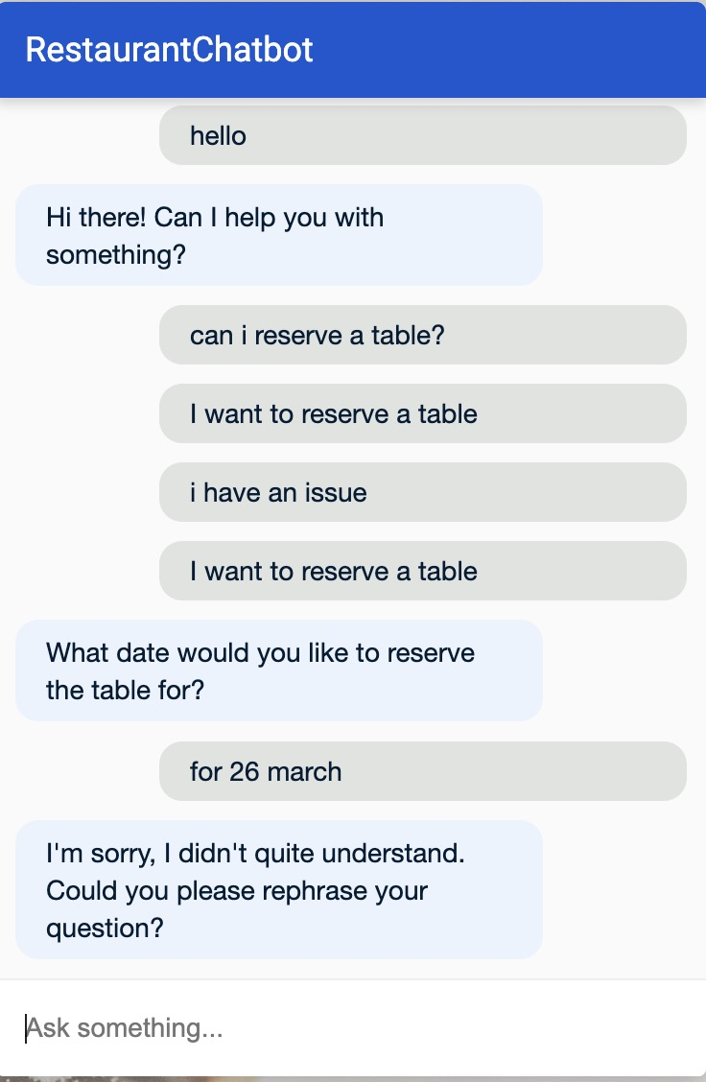

Second Screenshot:
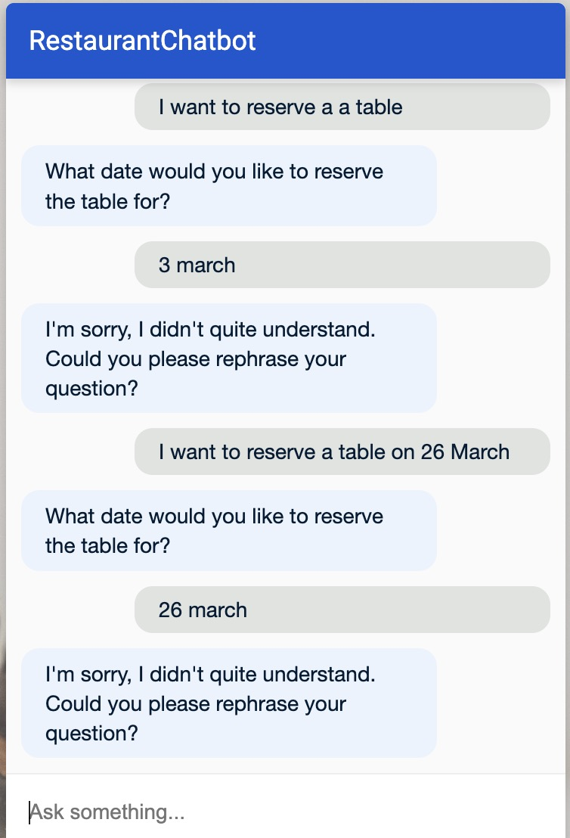

Third Screenshot:

- Test Cases

Test Case #01: Verifying Chatbot's Response to User Inquiries

Preconditions: | - The user has initiated a conversation with the chatbot.  - The system is successfully connected to the backend.
Actions: | - The user submits a query such as: "What are the restaurant hours?"  - The chatbot processes the query.
Expected Results: | - The chatbot should provide an accurate and relevant response, for example: "Our restaurant operates from 10 AM to 10 PM every day."  - The system should generate the response without any errors.
Tested by: | BC230424569
Result: | Pass

Test Case #02: Verifying Reservation Functionality
Preconditions: | - The user is interacting with the chatbot interface.  - The user has access to the reservation system.
Actions: | - The user requests to make a reservation, for example: "I want to reserve a table for four at 7 PM tomorrow."  - The chatbot processes the reservation and provides confirmation.
Expected Results: | - The chatbot should confirm the reservation, e.g., "Your table for 4 at 7 PM tomorrow is successfully reserved."  - The system should save the reservation information.
Tested by: | BC230424569
Result: | Pass

Test Case #03: Verifying Display of Reservation Details
Preconditions: | - The user has already completed a reservation.  - The system has stored the reservation details correctly.
Actions: | - The user inquires about the details of their reservation, such as: "What time is my reservation?"  - The chatbot retrieves the relevant reservation information and displays it.
Expected Results: | - The chatbot should display the reservation details, e.g., "Your reservation for 4 people is confirmed at 7 PM tomorrow."
Tested by: | BC230424569
Result: | Pass

Test Case #04: Verifying Menu Navigation Feature
Preconditions: | - The user has accessed the chatbot interface.  - The system is equipped with an up-to-date menu.
Actions: | - The user asks to see the menu, for instance: "Can you show me the menu?"  - The chatbot displays the list of available items along with their prices.
Expected Results: | - The system correctly displays the menu with item names and prices as expected.
Tested by: | BC230424569
Result: | Pass

Test Case #05: Verifying Order Placement Feature
Preconditions: | - The user has accessed the menu.  - The user is logged into the chatbot interface.
Actions: | - The user selects an item from the menu (e.g., "I’d like to order a pizza").  - The chatbot processes and confirms the order.
Expected Results: | - The chatbot confirms the order, e.g., "Your pizza has been ordered successfully."  - The system updates the order details accordingly.
Tested by: | BC230424569
Result: | Pass

Test Case #06: Verifying Modify or Cancel Order Functionality
Preconditions: | - The user has already placed an order.  - The system supports modifications or cancellations of orders.
Actions: | - The user requests to modify or cancel the order, e.g., "Can I change my pizza order?"  - The chatbot confirms the change or cancellation.
Expected Results: | - The chatbot should allow modifications or cancellations and update the system accordingly.  - The chatbot confirms the change, e.g., "Your pizza order has been updated."
Tested by: | BC230424569
Result: | Pass

Test Case #07: Verifying FAQs Responses
Preconditions: | - The user has opened the chatbot interface.  - The system contains a set of predefined FAQs.
Actions: | - The user asks a frequently asked question, e.g., "What time do you close?"  - The chatbot provides the relevant FAQ answer.
Expected Results: | - The chatbot should provide the correct response to the FAQ, and the reply should be accurate and timely.
Tested by: | BC230424569
Result: | Pass

Test Case #08: Verifying Handling of Invalid Input
Preconditions: | - The user is interacting with the chatbot.  - The user enters an unclear or invalid query.
Actions: | - The user inputs an ambiguous or incorrect query, e.g., "bljahsldksld" or "Can I order food?" without providing enough context.  - The chatbot asks the user for clarification or rephrasing.
Expected Results: | - The chatbot should respond with a clarification request, e.g., "Sorry, I did not understand. Could you please rephrase?"
Tested by: | BC230424569
Result: | Pass

